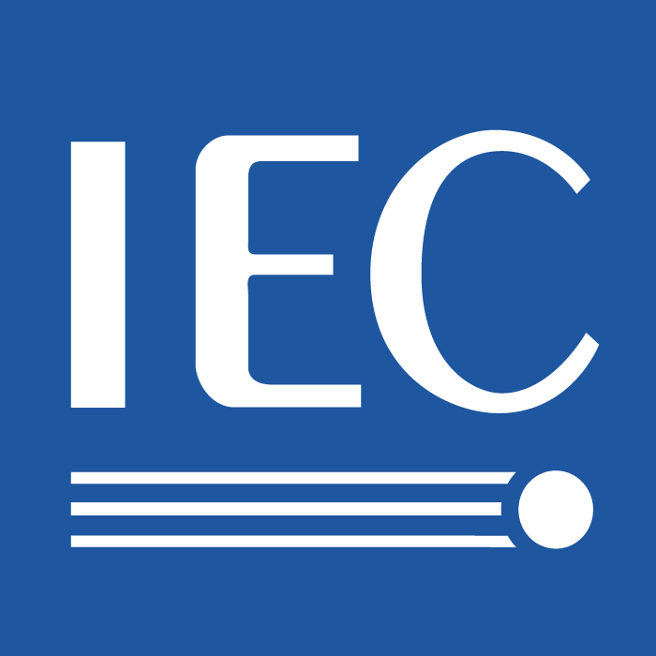  ® | 100/AGSxxx  For IEC use only  2012-5-15

INTERNATIONAL ELECTROTECHNICAL COMMISSION

TECHNICAL COMMITTEE 100: AUDIO, VIDEO AND MULTIMEDIA SYSTEMS AND
EQUIPMENT

AGS Study Session 5 report

1. About Study Session 5
It is based on the recommendation of AGS as;
“Recommendations and agreed action items, the 30th meeting of the TC100/AGS on Tuesday, 25 October 2011.
8. AGS identifies the requirement for standardization for multimedia equipment for electric vehicle and requests establishment of Study Session 5 appointing Mr. J. Yoshio as a leader of the session.”

2. Study
Yoshio formed Project Group to study issues of the study session 5 in JEITA, PG members are from manufactures that are making multimedia equipment for vehicle.
PG is studying the followings.
- Recognized that currently TC100 has no obvious standard regarding EV and vehicle, for instance,
there is no standards of car navigation.
- Strategic plan of AV multimedia regarding EV in TC100.
-- Not only EV but also all kind of vehicle is within the scope.
- Specific issues.
-- Network within vehicle and vehicle to outside.
--- Specifically, Ether network protocol becomes major in vehicle. It uses AVB to carry
AV data, AVB uses IEC 61883 series to carry AV data and can IEC 62379 series
for control.

3. Related activity
WSC’s Fully Networked Car conference was held in March, Yoshio attended from IEC/TC100.
It has been mainly ITS related conference, but the current progress of vehicle’s electronics system brings FNC concerns to more broad area of electronics and network technology.
FNC concerns are not only ITS area but also the area that TC100 should be concerned, because electronics and network system of vehicle includes infotainment area of TC100 inevitably.
TC100 needs further communication with ISO and ITU in this area.
(Refer “FNC report”.)

4. Next step
From the study of PG, Yoshio will make a proposal and expect to report to the next AGS.

