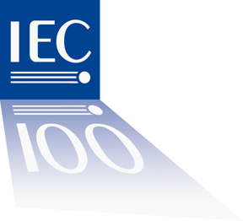 | TC8 AHG4  For IEC use only  2011-04

INTERNATIONAL ELECTROTECHNICAL COMMISSION

Requirements related Standards - Use Cases
Draft Agenda
Los Angeles, USA
May 11 - 12, 2011

Welcome

Introductions and AHG4 Roster

Opening remarks

Modifications / Approval of the draft agenda

Review of the inputs from the 8-9 March 2011 Workshop

Tasks and Organization (existing, to be created)

Update the IEC/PAS 62559 Use Case methodology– transform into International Standard

Update template, list of actors, glossary

Training on how to generate Use Cases (workshops, guides, ...)

Create/select tools for editing Use Cases, based on the template

Create/select tools for managing the Use Cases repository/versioning/traceability

Gather/collect & maintain generic Use Cases

Recommendations to SMB SG3 on : Use Cases categorisation, Describing/Setting-up an open process – involvement of all stakeholders

Discussion on future short-term actions/assignments

Date and place of the next AHG4 meeting

Adjournment

IEC Registered members ( 3 April 2011):

Ahn | Joonho | KR
CHOI | TAEIL | KR
Fatica | Alessandro | IT
Guise | Laurent | FR
Haim | Mario | DE
Hayashi | Hideki | JP
Hourdouillie | Régis | FR
Hwang | Woohyun | KR
Lambert | Eric | FR
Schomberg | Richard | Neutral Chair
Sinclair | John | GB
Volut | Serge | FR
Yamaguchi | Tatsushi | JP
Ziebell | Claus-Dieter | DE
Cleveland | Frances | US

