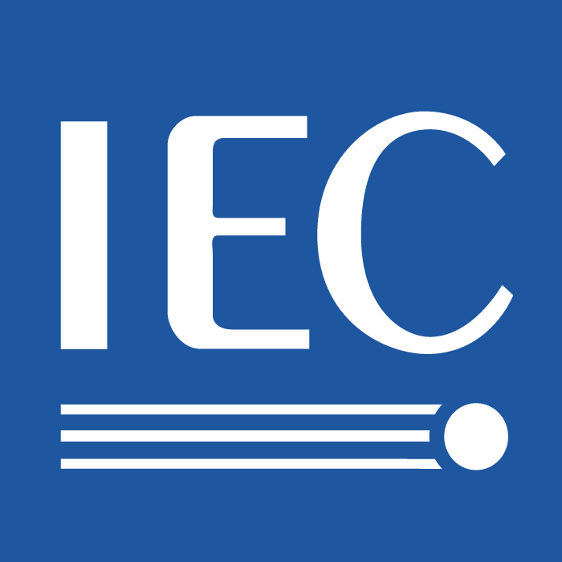 | 100/AGS(Secretariat)424r  For IEC use only  2010-10-11

INTERNATIONAL ELECTROTECHNICAL COMMISSION

TECHNICAL COMMITTEE No 100: AUDIO, VIDEO AND MULTIMEDIA SYSTEMS AND EQUIPMENT

Meeting minutes of the second meeting of the Future Technology Task Group (FT-TG) held in the Sheraton Hotel in Seattle, Washington

- Opening of the meeting by the Convenor
Dr. Mukai, FT-TG Convenor, called the meeting to order at 9:00 AM. The meeting followed the second draft agenda distributed prior to the meeting. (Mikio.Mukai@jp.sony.com)

- Roll call of the participants
Convenor: Dr. Mikio Mukai
Members:

Yushi Komachi
Keith Jones
Jean Baronas
Ulrike Haltrich
Norimasa Minami
Shuij Matsumura
Junichi Yoshio

Observers:
Tadashi Ezaki
Toshihiro Inokuchi
Kim Young-Hwan
Jon Fairhurst
Hironori Sakakihara
Chen Ren
Chuljoo Jeon
Huayi Zhan
Fan Kefeng
Zhang Subing
Hiroaki Muraoka
Kyu-sik Choi
Hiroyuke Iga
Jeff Howell

3.0 Adoption of the agenda
The participants agreed to accept the agenda (FT-TG 14) without modification.

4.0 Review of meeting minutes from the Athens meeting
The minutes from the May 18 meeting were reviewed (FT-TG 10) and accepted without modification.

- Review of the related documents from the IEC/TC100
The scope (“draft plan”) of the FT-TG was reviewed and abbreviated for these minutes: to review the PACT report: “Final report of the Human interfaces in Multimedia network Era” (2001-11-12, 100AGS63, and the report to the Firenze AGS) and the response to the PACT Report (2003-11-04, 100AGS111, 112, and the report to the London AGS). The scope also includes requesting contribution for future strategies and to discuss such ideas with the IEC TC100 AGS.

While the FT-TG reviewed FT-TG 12 (SMB topics for future strategies), Mr. Norimasa Minami also noted that FT-TG participants should also study the new IEC Whitepaper, “Electrical Energy Efficiency” developed by the IEC Market Strategy Board (MSB) which was approved by the IEC Council Board on 10 June 2010. Specifically, page 39 addresses home architecture. As an action item,

Mr. Minami noted that the FT-TG members should study this material and begin to analyze the relationships addressed in this document with future standardization in the IEC TC100.

The FT-TG listed the following as possible new topics / strategies for the IEC TC 100. These are reflected in FT-TG 12 and expanded and modified as follows (listed in no particular order):
- Smart Grid
- 3DTV
- Mobile phone related applications
- Mobile identification and payment
- Electric vehicle
- Electronics in the automotive field
- Flat panel display components
- Bicycle navigation, power assist
- Networking
- Remote access to multimedia
- Copyright, DRM (Digital Rights Management), and law
- Maritime, ship
- Security 2010 crisis
- Hearing and sound collection aid
- Error correction
- Application side of high-voltage systems
- Smart Home
- Intelligent sensors
- Automated sensors and controls
- Energy saving technologies including reduced stand-by losses
- Measurement system(s) for energy efficiency for LED back light (in liaison with IEC TC110, total system approach with input from the IEC TC100). This area can include video display systems’ power usage / luminous efficiency for typical use cases
- Measurement system(s) for digital amplifiers (low power/appeal could be emphasized)
- Measurement system(s) for speaker energy efficiency
- External power supplies and battery chargers (to potentially cover more than for computers; the work should be “more general”)

6.0 Future models and frameworks
Mr. Junichi Yoshio presented a contribution on future models and frameworks (AGS FT-TG16 and FT-TG 09) which covers homes, cars, and data and network services (security, energy efficiency, accessibility, quality, identification and other items). A user communication structure was presented and this could also be used. As an action item,

The FT-TG members are asked to study the approach on models and frameworks (FT-TG 16 and FT-TG 09).
The participants noted that IEC 61998 (a TR) will be distributed for future maintenance and the models and frameworks presented by Mr. Yoshio, along with contributions from others could be contributed.
7.0 History and progress for consumer and audio video
Mr. Junichi Yoshio presented FT-TG 19. He noted the progress of consumer electronics, including providers, services, network storage, and content distribution and output. He also noted the IEC TC100 Technical Areas (TAs) working in the related areas. Additionally, the concept of networks and PCs driving future IEC TC100 equipment and systems was discussed. As an action item,

The FT-TG members should study FT-TG 19 for consideration for future IEC TC100 strategies.

8.0 Personalization of information interchange
When he presented FT-TG 18, Mr. Yushi Komachi noted considerations of functionality, user requirements and user preferences in cases such as mobile phones/systems, wizards, navigation systems and other applications that store personalized information. Such applications could present a future area of standardization for the IEC TC100. As an action item,

The FT-TG members are encouraged to study the proposal on the issue of personalization of information interchange (FT-TG 18).

- Next steps
The FT-TG members agreed to, either as individuals or by working with others, to the following action items:
- Select one or two technology topic areas (listed above in Section 5) by the end of October 31, 2010 and send the idea to the convener.
- The convener will respond back immediately to confirm the technology topic areas. NOTE: In addition, other input from other interested members of the IEC TC100 is welcome.
(c.) The FT-TG members agreed to report to the Convener by January 31, 2011 on:
(i.) the present situation (of their topic),
(ii.) timeframe / timeline: when the selected technology will be available for standardization
(iii.) the related standardization organization,
(iv.) the possible standardization item / relationship with the IEC TC100. program of work, and
(v.) the FT-TG members shall classify the possible topic(s) [automotive, maritime, displays, etc.]
The convener will compile and analyze the studies and report back to the FT-TG members by March 31, 2011. The convener will also report to the IEC TC100 AGS (Madrid).

- Next Meeting
The third meeting of the FT-TG will be held in Madrid, Spain on 4-25-2011 (in the morning) prior to the AGS meeting.

