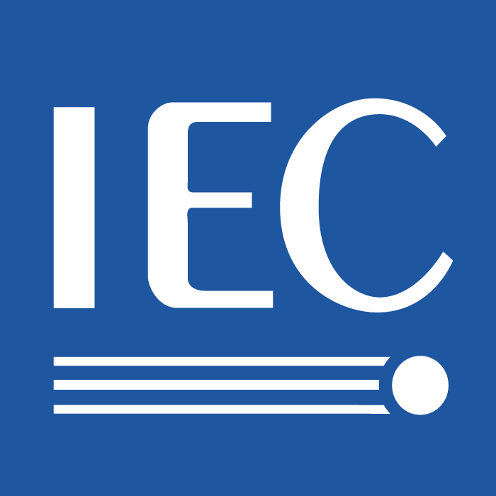 | 100_FT-TG_minutes_2010-05-18  For IEC use only  2026-10-18

INTERNATIONAL ELECTROTECHNICAL COMMISSION

TECHNICAL COMMITTEE 100: Audio, Video and Multimedia Systems and Equipment

AGS/Future Technology Task Group (FT-TG)

Minutes for the meeting of FT-TG

Date & Time: 2010-05-18, 9:00 – 12:00
Place: Hotel Divani Place Acropolis, EREHTHION meeting room, Athens, Greece

1. Opening of the meeting and roll call
TC 100 Chairman, Mr. Mark Hyman started the meeting with a short greeting. Mr. Alexandros Psyrris, ELOT welcomed all participants to Athens.

2. Roll call
Roll call was done by self-introduction. There were 17 attendees from AU, DE, JP, NE, US and USB IF. The attendee list is attached.

3. Approval of the agenda
The draft agenda was reviewed. There was a comment the numbering of items doubled. The revised agenda was approved.

4. Confirmation of Title and Scope of STG
The title and the scope of this group were reviewed based on the document, STG07, and discussed. It was agreed to the new title of AGS/Future Technology Task Group (FT-TG) and that the group reports to AGS.
The scope was accepted without any change.

5. Review of the related documents from IEC/TC100 and AGS
The convener, Dr. Mukai introduced the background of establishment of this task group and some documents recorded in the past, based on the document, FT-TG 07 referencing to FT-TG 01 through FT-TG 06.

6. Contributions to STG
6.1 Mr. Yoshio
Mr. Yoshio introduced his views and proposal for future technology standardization based on the document FT-TG 08 including IPTV, user interface, home networking and security.

6.2 Ms. Haltrich
Ms. Haltrich introduced about topics regarding “Standards Year” event. Energy efficiency and environmental issues are addressed as well as accessibility and usability.
Dr. Hirakawa commented accessibility is addressed in ITU-R arena.
Dr. Komachi commented that PACT report was excellent but new technology was not included such as energy efficiency, accessibility and e-book content format.

6.3 Discussions
The convener showed new technology areas including brain storming topics to be considered:
- Smart Grid
- Environment impact to TC100 or environment aspect
- Accessibility (is in progress)
- PC related issue (with multimedia), (already in TC100 scope)
- IPTV
- Mobile identification and payment
- Cloud computing
- Battery charger
  - Mobile phone charger
  - Chargers for automobile related
  - ITU-T SG5, liaison statement, l.100 on electric charger, l.100 defines just general profile
  - Chargers for multimedia
  - Wireless charging system
- 3D TV
- Energy efficiency (TA 12)
  - External power supply (EPS)
  - CENELEC now developing EPS box, attached as mandate
  - TC100 needs battery charging interface, SC48B discussion, will be introduced in AGM

Dr. Komachi suggested initiating a kind of brainstorming discussion for the enhancement on this topic.

Dr. Hirakawa commented that TC100 should be more strategic to cover future e-book. This is now on issue and will be discussed at AGS and AGM. He also mentioned that visibility of TC100 standardization is important and needs to educate people so that can understand better. Ms. Baronas commented that how to promote TC 100 from IEC Central Office point of view is important, and also important of the education. In order to make it practical, who, where, when how and what approach would be important.
Mr. Fairhurst commented in addition, applicability would be also important.

Mr. Matsumura commented that promotion and education issues are important, but it would be the task of another group under TC100 AGS or AGM.

It was commented that all the PC issues are already discussed and already in progress under TC 100 depending on the topics which is under the scope TC100.
It was commented that Environmental issues will include energy efficiency but it was noted that all the TCs should address environmental issues in the TC.
Mr. Minami introduced a report from SMB/SG 1. Ms. Baronas will address TC 100 response against the SG 1 recommendations. Mr. Keith Jones also mentioned about the external power supply (EPS) related with Battery charger interface, but this is related with energy efficiency. Ms. Haltrich addressed automobile related issues in reference to battery charger interface issues.

Dr. Komachi introduced International Cooperation for Education about Standardization (ICES) as education activities.

7. Any other business
None

8. Conclusions of the STG meeting
The convener summarized the discussion today and will report the result of the meeting to AGS tomorrow.

9. Subsequent meeting planning
The next meeting will be held in Seattle. In between, we would discuss vir e-mails.
The convener noted that the group will discuss and conclude the future technology task group discussion shorter than two years.

11. Close of the meeting
The convener thanked members for attendance and co-operation and closed the meeting.

------

Attendee list

Members;
Convener: Mikio Mukai
Members: Yushi Komachi
Shuji Hirakawa
Jean Baronas
Ulrike Haltrich
Keith Jones
Shuichi Matsumura
Eric van Nijhuis
Junichi Yoshio

Observers:
Tadashi Ezaki
Jon Fairhurst
Megan Hayes
Hiroyuki Iga
Norimasa Minami
Hironori Sakakihara
Stephen Wood

