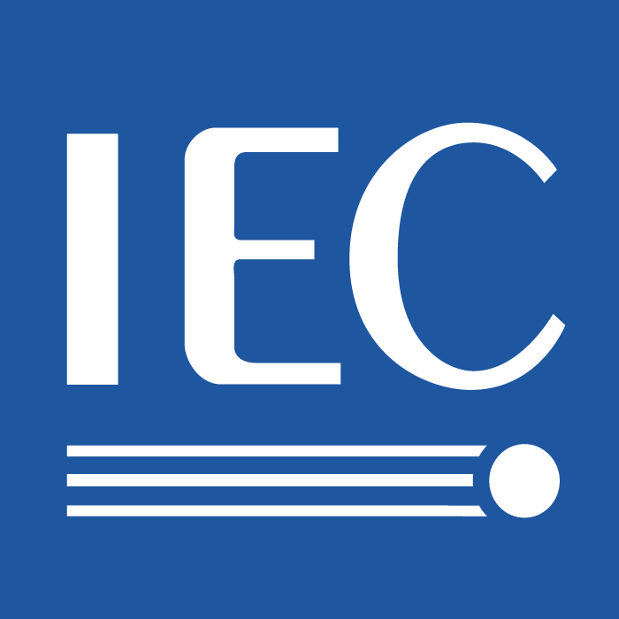 | 100/AGS(Secretariat)361  For IEC use only  2009-05-20

INTERNATIONAL ELECTROTECHNICAL COMMISSION

TECHNICAL COMMITTEE No 100: AUDIO, VIDEO AND MULTIMEDIA SYSTEMS AND EQUIPMENT

ADVISORY GROUP ON MANAGEMENT

The Report of the First Ad-Hoc of IEC TC100 High-Level meeting on May 1st, 2009, in Geneva, Switzerland.

--------------------------

Date: May 1st, 2009, 9:00 – 13:00
Place: Room Lord Kelvin of IEC Central Office in Geneva, Switzerland.
Participants:
Mr. Gabriel Barta, IEC Central Office member of ISO/IEC JTC 1
Mr. Matei Cocimarov, IEC Technical Officer- TC100
Mr. Simao Ferrraz De Campost, Counsellor of ITU-T SG 16
Ms. Karen Higginbottom, Chairman of ISO/IEC JTC 1 (phone)
Mr. Shuji Hirakawa, Secretary of IEC TC100
Mr. Mark Hyman, Chairman of IEC TC100
Mr. Masahito Kawamori, ITU-T IPTV GSI Coordination Manager
Mr. Yushi Naito, Chairman of ITU-T SG 16
Mr. Arthur Webster, Chairman of ITU-T SG 9

1. Opening:
Roll call of delegates
Those in attendance in person or on the phone introduced themselves by name and affiliation.

2. Approval of the agenda
The agenda was approved as circulated.

3. Report of the first TC 100 High Level Meeting on November 20th in Sao Paulo.
The meeting report was not approved at this meeting.
It will be added for approval at the next meeting.

4. Discussion how to collaborate among IEC TC 100, ISO/IEC JTC 1 and ITU-T
Dr. Hirakawa explained the background to the first meeting and highlighted SMB Decision 132/9 – that agreed with TC 100/AGS recommendation2 for a collaboration group between IEC TC 100 Chairman and Secretaries and relevant ITU-T Study Groups’ Chairmen on the subject of home-network and IDTV receiver standardizations on IPTV systems and/or equipment, and recommended representation from TC 100, JTC1, ITU and ETSI in order to set up a better cooperation between these different bodies.
Ms. Higginbottom who was on the telephone acknowledged that she did not have the previous handouts from the former JTC1 Chairman but JTC1 has responded positively to several actions that have improved the relationship with both TC100 and the ITU. She acknowledged the liaison of Dr. Kate Grant between TC100 and JTC1.
It was noted that JTC1 has a work item relating to common text that is being developed with ITU /SG16 and this text will be retained by JTC1 as proposed. This project is expected to be ongoing over the next 18-24 months.
There was discussion relating to how joint IEC/ITU and ISO activities have been and need to be established. It was noted that between JTC1 and ITU there is mutual activity established at the Study Group level. Similarly in IEC the Technical Areas could establish a similar work relationship. Mr. Barta from IEC Central Office noted that new activities could also be established at the Technical Committee area. After further discussion it was agreed that this needs further exploration.
Dr. Hirakawa stated that he would introduce mutual activity between ITU and IEC TC100 in the future. This hopefully will lead to dual logo status upon completion of mutually agreed upon projects. (Secretary’s note: At this point because of early hours, Ms. Higginbottom was thanked and left the phone bridge)

- Possible items for collaboration
Dr. Hirakawa highlighted the structure of TC100 and noted that are current collaborative
Activities with other organizations including DLNA (IEC 62455) DVB BlueBook A132 IEC/DLNA and DVB IPI exchanging liaison documents in early 2009. He also pointed to IEC 62481: Digital living network alliance (DLNA) home networked device interoperability guidelines – Part 1: Architecture and protocols and Part 2: DLNA media formats. DVB Bluebook A138: High-level Technical Requirements for QoS for DVB Services in the Home Network. He then questions other possible cases between ITU-T and IEC?
Dr. Kawamori of the ITU then gave a presentation on activities within his Study Group highlighting a few collaborative areas. Dr. Kawamori noted that within ITU there have been efforts relating to H.701, H.720, H.721, H.750, H.760 and H.761. He reported that a joint meeting was held with IEC TC100 TA8 relating to issues on rights information and metadata for IPTV. Noting that this was the first official activity between ITU - T and IEC TC100. He stated that also there had been receipt of a liaison statement from TC100 activity on STB power consumption.
Dr. Hirakawa pointed to possible overlap areas that could be identified.
The group had a discussion on the drafting of a general statement and the identification of short-term goals for collaborative work.
It was agreed that a “boiler-plate” statement on joint ITU and IEC activities would be drafted along with the identification collaborative areas between the groups.
(Annex A –general statement drafted by the group)
(Annex B- identification of short-term collaborative areas)
The group stated that although a number were not in attendance the distribution list would include organizations as identified including ETSI

5. Date and place of next meeting
The next meeting will take place after the IEC TC100 meetings next October in Tel Aviv, Israel. The location will probably be Geneva at the IEC Central Office.

Documents of the meeting:

1_Ad-Hoc 090501 Draft Agenda.ppt
2_Ad-Hoc 090501 TC100 Introduction.ppt
3_Ad-Hoc 090501 TC100 Presentation.ppt
4_Ad-Hoc 090501 TC100 Discussion.ppt (modified partly during the meeting)
5_First_RII_Joint_Meeting_E1 Final.doc
6_ITU-T-IPTV-intro.ppt
7_IEC_ITU-T TOR.ppt (Output of the meeting)

Annex A: Collaboration areas of IEC TC 100 and ITU-T relevant to IPTV and HN
- IPTV receiver and terminal Issues
  - Title of TA 1 is ‘Terminals for audio, video and data services’
  - Recent TV and STB definitions include a broadband input
  - The title of ITU-T Q 13/16 is ‘multimedia application platforms and end systems for IPTV’
- Home and end-user network issues
  - IEC 62481-1, 2 Ed.1 (DLNA specifications) are now included in ITU-T (Draft New) Recommendations as normative references
  - (ISO/IEC JTC1 SC25 is to be informed)
- Rights information interoperability
  - IEC 62227 (2008-06) Ed. 1.0: Multimedia home server systems - Digital rights permission code
- Cable television facility Issues
- Other Issues
  - DTCP-over-IP (maybe in TA 9) ◊ Filled out by IEC 62481 Part 3.
  - HDMI (maybe in TA 1 or 4) ◊ Still open-gap ⇓ Chinese DiiVA??
- QoS issues within Home NW.
  - Boundary between Resident Gateway and Terminal (where is the UNI?)
  - ISO/IEC JTC1 SC25 and ITU-T SG12 are to be informed
  - Cooperate to create a “parallel text” rather than the “common text” of JTC1.
- Energy efficiency issues
  - ITU-T SG5 is to be informed

Annex B:
- Organizations to be informed of this agreement:

  - ISO/IEC JTC1
  - ITU-T IPTV JCA and GSI + SG5
  - DVB project
  - ETSI TISPAN
  - ETSI STQ
  - ATIS IIF
  - OMA
  - OpenIPTVForum

Annex C:
- Work plan is to be decided
- Next Meeting Schedule
  - To meet in Geneva after the IEC Tel-Aviv meeting, 18(sun)-22(thu) October 2009, perhaps during the decided dates of ITU-T SG9&16 meeting.

Annex D: Relevant ITU-T meetings
- ITU-T IPTV-GSI: 22-26 June 2009, Geneva
- ITU-T SG5 meeting: 25-29 May 2009
- ITU-T IPTV-GSI:
- ITU-T SG9&16 Meeting: 26-30 October 2009 (venue to be decided)

- - - - - - -

