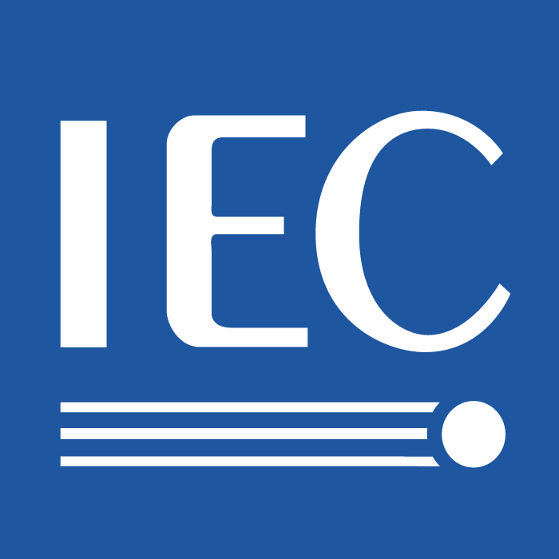 | [Document reference]  Terms of reference of TA/GMT
 | IEC/TC 100  TA 12 | Secretariat  Japan | Date  May 11, 2009

Title of TA
Energy Efficiency

A. Scope

This Technical Area (TA) is responsible for developing the standard measurement methods for the power use of televisions, set top boxes (STB), audio equipment, multi-function equipment, and information and communication technologies (ICT) such as laptop and desktop computers. The measurement methods will address equipment that connects to the power mains. The measurement methods will also address normal use conditions. To the extent practicable, the participants in this TA will evaluate and potentially define the various operating modes in terms of their power use. The participants will also consider the approaches for saving energy through the standardization of control mechanisms in networked multimedia equipment. The safety of the measurement methods is out of this TA’s scope.

B. Justification

Having recently completed a standard for the measurement methods of the average television’s power use, the TC 100 remains interested in and committed to standardizing energy use metrology. The IEC 62087: 2008 (E) Ed. 2.0 BD, “Methods of measurement for the power consumption of audio, video and related equipment” was developed by the TC 100 and recently published, late 2008. This activity, which attracted numerous participants and stakeholders, culminated in broad industry participation. The resulting standard is referenced in some legislation and currently under consideration for some regulatory regimes.
Subsequently, the TC 100 initiated a project to standardize a method of measurement for the power use of Set-Top Boxes (STB) mainly in the on mode and standby-active, high mode. These modes correspond to the actives modes which will be defined in IEC 62542 Ed.1. MT 62087, IEC 62087 Ed. 3.0 (1CD) was circulated under 100/1528/CD 2009-03-20.

A presentation on “Saving Active Standby Power (ASP) of Home Network Appliances” by Mr. Kwang-Soon Choi at the TC 100 Advisory Group on Strategy (AGS) in April 2008, initiated technical discussions about energy efficiency through networked multimedia equipment. In May 2009, the Korean National Committee of the IEC submitted a New Work Item Proposal to the Secretary of the IEC TC 100 for an “Energy Saving System for home appliances and home network devices – Part 1: Architecture and requirements.” The proposal describes potential, follow-on, consecutive proposals for an Electric Power Control and Management (EPCM) Protocol for an Energy Saving System (ESS), the Acquisition of Electric Power Attributes of Home Network Devices, and a Real-time EPCM Platform for ESS. The status of Part 1 remains pending.

The TC 100 TA on Energy Efficiency intends to contribute “operating conditions with respect to power demand” to the IEC TC 111 (Environmental standardization for electrical and electronic products and systems) Project Team 62542. The TA would also collaborate with other IEC groups active in energy efficiency, as appropriate.

The TC 100 also considers the strategy for energy efficiency standardization. Specifically, the IEC TC 100 Task Force (TF) for Energy Efficiency investigates energy efficiency related to the standardization work in the TC 100. The TF also considers and develops responses to the recommendations set forth by the IEC Standards Management Board (SMB), Strategic Group (SG) 1 on Energy efficiency and renewable resources. The TF was established under the TC 100 / Advisory Group on Strategy (AGS) in November 2008 and will remain active in establishing a TC 100 strategy for energy efficiency. The TF participants are encouraged to develop the potential to integrate energy efficiency principles in the TC 100 program of work and to recommend future energy efficiency activities to the TC 100 AGS. The TF asserts that the content, format, and criteria for energy efficiency labels remain outside of the TC 100 scope of work. Further, the TF concludes that third party testing for energy efficiency and energy efficiency classification systems remain outside of the scope of the IEC TC100.

C. Officers
B.1 Technical Area Manager (TAM)
Nominated by the TC 100 Secretariat for appointment by TC 100 chairman
Proposed by Technical Area Manager
Mark Hyman Jean Baronas
B.2 Technical Secretary (TS)
Nominated by the TC 100 Secretariat for appointment by TC 100 chairman
NC Technical Secretariat Technical Secretary
Japan Hiroyuki Iga

D. Work programme
Allocated projects and milestones:

- IEC 62087, Edition 2, “Methods of measurement for the power consumption of audio, video and related equipment,” October 15, 2008. The Maintenance Result Date: 2010.
- MT 62087, IEC 62087 Edition 3.0 (1CD),” Methods of measurement for the power consumption of audio, video and related equipment.” The 100/1528/CD was circulated 2009-03-20 and closing date for comments is 2009-06-26.

E. Liaisons
Liaisons:

(1) IEC TC 108 (“Safety of Electronic Equipment within the Field of Audio/video, Information Technology and Communication Technology”)
(2) ISO/IEC JTC1 SC28 (“Office Equipment”)

A liaisons:

B liaisons:

D liaisons:

Name or signature of the secretary
Shuji Hirakawa

FORM TC 100 TA
2005-06-10

Work programme for TC 100/TA 12

(1) IEC 62087: 2008 (E) Ed. 2.0, BD, Methods of measurement for the power consumption of audio, video and related equipment

(2) MT 62087, IEC 62087 Ed. 3.0 (1CD), Methods of measurement for the power consumption of audio, video and related equipment

(3) New Work Item Proposal, Energy Saving System (ESS) for home appliances and home network devices – Part 1: Architecture and requirements, submitted by the Korean National Committee of the IEC, May 5, 2009.

