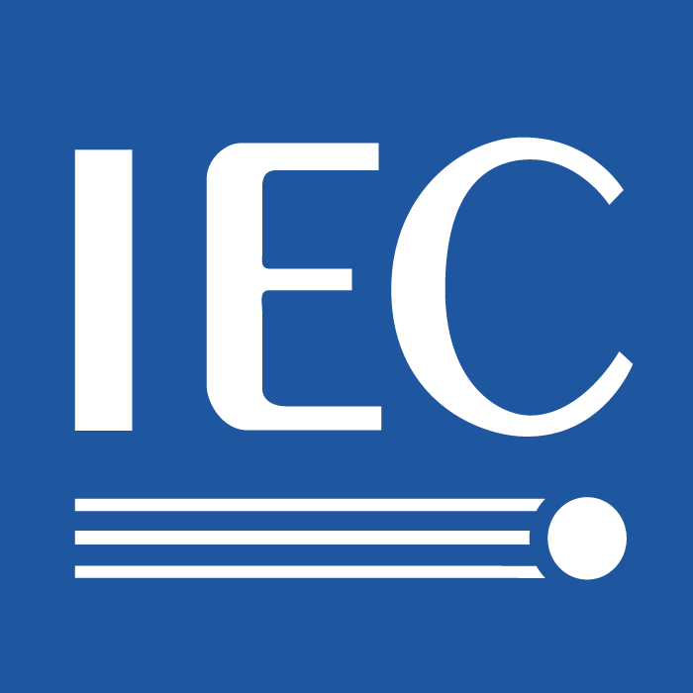

INTERNATIONAL ELECTROTECHNICAL COMMISSION

TECHNICAL COMMITTEE No. 100: AUDIO, VIDEO AND MULTIMEDIA SYSTEMS AND EQUIPMENT

May 1, 2009

To: The IEC Standards Management Board (SMB)

From: The IEC TC100

Subject: Input from the IEC TC100 on the IEC SMB/SG1 Energy Efficiency and Renewable Resources - Report to SMB following the 4th meeting held on 2008-06-04 in Geneva, Switzerland and the 5th meeting held on 2008-10-30 in Orlando, Florida US; SMB/3970/R

Smart Grid, SG 1 Recommendation 13:

IEC to organize a Workshop on the topic of “Advanced supply and demand side
balance in electrical grids” in order to inform on the state-of-the-art in standardization
and to further propose concrete new standardization activities. This encompasses
a) the integration of renewable energy sources into existing grids as well as
b) techniques aiming at the optimization of electricity supply versus electricity demand. TC 8, TC 57, TC 13 Primarily concerned IEC/TCs are TC 8 “System aspects of electrical energy supply” and in particular TC 57 “Power systems management and associated information exchange”. Recommendation introduced by SMB/3865/DC, Household appliances.

Position of the IEC TC100 on Recommendation 13:

The IEC TC100 supports Recommendation 13. The IEC TC100 supports the idea of consideration of a Workshop on "Advanced supply and demand side balance in electrical grids" to communicate the state-of-the-art in standardization and to further propose new standardization activities. In the interest of economical considerations and practicalities, the related discussions could be carried out by using online discussion forums such as a bulletin board to post comments and place the related documents.
Please note that on the usage side of the grid, the IEC TC100 offers the following information: the IEC TC100 intends to consider a new IEC TC100 Technical Area (TA) on Energy Efficiency. The following IEC TC100 standards: IEC 62087: 2008, Methods of Measurement for the Power Consumption of Audio, Video, and Related Equipment; IEC 62394: 2006, Service Diagnostic Interface for Consumer Electronics Products and Networks --- Implementation of ECHONET; and the IEC 62514, Edition 1: 100/1526/CDV Guidelines for Multimedia Gateway in Home Networked, in addition to an idea / concept for a proposal entitled "Saving Active Power (ASP) of Home Network Appliances" address some aspects of the usage side of the grid.

Household Appliances, SG 1 Recommendation 14:

TC 59 and its SCs to develop/update International Standards on measurement procedures required to define energy efficiency classes of electrical household appliances. The relevant evaluation methods shall take into account a realistic simulation of the actual use of each type of appliance. Recommendation introduced by SMB/3865/DC, 8/9 SMB/3970/R.

Position of the IEC TC100 on Recommendation 14:
The IEC TC100 supports Recommendation 14 to the extent that the IEC TC59 and the IEC TC59 subcommittees support the Recommendation. Please coordinate this work with the IEC TC100 contributions to the IEC TC111 Project Team (PT) 62542.
Household Appliances, SG 1 Recommendation 15:

TC 59 and its SCs to develop a harmonized international system of energy consumption classes including a labeling scheme to determine the energy consumption/energy efficiency of household appliances, taking into account the existing regional and national standards in this field. Recommendation introduced by SMB/3865/DC.

Position of the IEC TC100 on Recommendation 15:

The IEC TC100 supports Recommendation 15 to the extent that the IEC TC59 and the IEC TC59 subcommittees support the Recommendation. Please note that an energy consumption (use) classification scheme, including labeling, is out of the scope of the IEC TC100.

Household Appliances, SG 1 Recommendation 16:

TC 59 and its SCs to take into account both standby losses and off-mode losses in their product standards. Note: Definition of standby mode(s) and off-mode losses, as well as measurement techniques, needs to be harmonized throughout IEC Technical Bodies Recommendation introduced by SMB/3865/DC.

Position of the IEC TC100 on Recommendation 16:
The IEC TC100 supports Recommendation 16 to the extent that the IEC TC59 and the IEC TC59 subcommittees support the Recommendation. Please coordinate this work with the IEC TC100 contributions to the IEC TC111 Project Team (PT) 62542.

Household appliances, consumer products, IT products, SG 1 Recommendation 17:

TC 96 “Small power transformers, reactors, power supply units and similar products” to take into account standby operation and energy efficiency of power supplies in their standardization activities. Note: Definition of standby mode(s) and off-mode losses, as well as measurement techniques, need to be harmonized throughout IEC Technical Bodies. Recommendation introduced by SMB/3865/DC.

Position of the IEC TC100 on Recommendation 17:
The IEC TC100 supports Recommendation 17 to the extent that the IEC TC96 supports the Recommendation. Please coordinate this work with the IEC TC100 contributions to the IEC TC111 Project Team (PT) 62542 (defining the operating modes). The modes should eventually be harmonized.

IT equipment, consumer electronics, SG 1 Recommendation 18:

TC 100 and TC 108 should take into account both standby losses and off-mode losses in their standards. This implies external power supplies (AC / DC converters) to be considered as integral parts of the pertinent equipment (i.e. same treatment as for internal power supplies). For true zero standby and off-mode losses, the power supply shall be completely disconnected from the mains power by appropriate means. Recommendation introduced by SMB/3865/DC.

Position of the IEC TC100 on Recommendation 18:

Unfortunately, the IEC TC100 cannot support Recommendation 18. The IEC TC100 plans to continue developing energy efficiency measurement standards which provide neutral approaches (technology-independent) for the study and comparison of power use. The IEC TC100 does not support the idea, however, set forth in Recommendation 18, of standardizing the requirements for the design of "zero standby and off mode losses." Such requirements would be promulgated, per their mission statements, by the related governmental agencies with full consideration of the social and economic impacts. The IEC TC100 plans to continue working in close collaboration with the IEC TC108. The SG1 met in Paris, France in March 2009 (minutes: SMB-SG 1/0065/RM) and concluded that defining the metrics and methods of testing (for energy efficiency) is the task of the IEC TCs and the regulators' task "are to fix the limits." As such, this SG1 perspective matches the spirit of the IEC TC100 plans to continue developing energy efficiency measurement standards which provide neutral approaches for the comparison of power use.
IT equipment, consumer electronic, SG 1 Recommendation 19:

TC 100 and TC 108 to develop/update International Standards on measurement procedures for IT equipment and consumer electronics, which are the basis for
establishing energy consumption / energy efficiency classes or other performance indicators. Recommendation introduced by SMB/3865/DC.

Position of the IEC TC100 on Recommendation 19:

The IEC TC100 supports the first portion of Recommendation 19: the IEC TC100 has and will continue developing / updating International Standards on measurement procedures, such as the IEC 62087, intended for technology-independent measurement and comparison of energy consumption (use). The IEC 62087 standard is considered, and in some cases used, as the basis of regulation, in some cases, where the regulations provide the energy levels. Performance has changed over time, and is expected to continue changing. Therefore, the standardization of performance indicators, which can take the form of in-situ measurement and readout, is an unlikely candidate for standardization. If by "performance indicator," the SG1 connotes "labeling," labeling is out of the scope of the IEC TC100. Absent explicit definition of "performance indicator," the IEC TC100 responded to two interpretations of the term.
The IEC TC100 plans to continue collaborating with the IEC TC108 on energy efficiency, including the technical domain of Information, Communication, and Telecommunication (ICT). As mentioned, the IEC TC100 supports the portion of Recommendation 19 which describes measurement procedures. However, the IEC TC100 cannot support the concept of having the responsibility for any energy consumption / energy efficiency classes or other performance indicators which is the second part of Recommendation 19.
IT equipment, consumer electronics, SG 1 Recommendation 20:

TC 100 and TC 108 to develop a harmonized international system of energy consumption classes or other performance indicators including e.g. a labeling scheme to determine the energy consumption / energy efficiency of consumer electronic products, such as TV sets, set-top boxes, cable modems, DSL routers etc.
Recommendation introduced by SMB/3865/DC

The IEC TC100 position on Recommendation 20:

Unfortunately, the IEC TC100 cannot support Recommendation 20. The IEC TC100 plans to continue collaborating with the IEC TC108 on energy efficiency, including in the technical domain of Information, Communication, and Telecommunication (ICT) in the area of energy efficiency performance measurement. However, classifications, performance indicators, e.g., a labeling scheme are out of the scope of the IEC TC100. Therefore, the IEC TC100 cannot support Recommendation 20.
For further information, please contact: Shuji.Hirakawa@toshiba.co.jp

