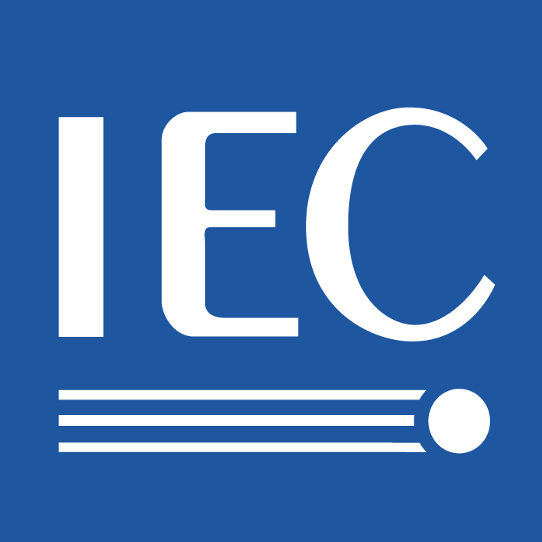 | Minutes of TC 100_JTC 1_ITU-T High-level meeting on 081120  For IEC use only  2026-01-23

INTERNATIONAL ELECTROTECHNICAL COMMISSION

TECHNICAL COMMITTEE 100: Audio, Video and Multimedia Systems and Equipment

Minutes for the meeting of ITU-T, ISO/IEC JTC 1 and IEC TC 100

Date & Time: 2008-11-20, 15:45-18:00
Place: WTC Hotel, room Curitiva, Sao Paulo, Brazil

1. Opening of the Meeting
The TC 100 Secretary, Dr. Hirakawa opened the meeting.
Roll call was made. During the call, it was announced that Mr. Scott Jameson of JTC 1 Chairman received Lord Kelvin Award this year and all the participants congratulated him.
There were 23 attendees. The attendee list is attached.

2. Approval of the agenda
The proposed agenda was reviewed and approved.

3. Introduction of High Level Meeting of TC 100
Dr. Hirakawa explained the background of this meeting to be held based on the document, 3_100_Highlevel SMB132_R9 implementation 081120.

4. Presentations for introducing each group
4.1 IEC TC 100 including relevant Technical Areas 1, 5, 8 and 9
Dr. Hirakawa introduced TC 100 and TAs based on the document, 4_TC 100 Relevant Technical Areas 081120. TA 1, 5, 8, 9 and 11 were highlighted as the relevant TAs to the high level meeting. Current standardization activities relevant to the high level meeting were introduced. A success story of collaboration on digital broadcasting system was introduced. Possibility of new item for power consumption measuring method was also introduced.

4.2 ISO/IEC JTC 1
ISO/IEC JTC 1 Chairman, Mr. Scott Jameson introduced activities of ISO/IEC JTC 1.
JTC 1 has currently 17 SCs and SCs 6, 25, 27 and 29 were highlighted as the relevant SCs for the possible collaboration.

4.3 ITU-T SG(s) including ITU-T WP 2/16 and its Rapporteur Groups for End Systems
ITU-T SG 16 Chairman, Dr. Kawamori introduced new ITU-T SG structure which was decided in the WTSA in late October 2008. Questions in SG 16 were introduced. Questions in area B are related to this high level meeting agenda. ITU-T recommendations for IPTV were introduced. IEC 62227 was noted as a related TC 100 standard.

4.4 ETSI and its TISPAN WG 5 for End Systems
Dr. Hirakawa invited ETSI representatives to this meeting, however no one appeared from ETSI this time.

5. Discussion of the current situations
Dr. Hirakawa proposed that we should create a discussion framework.
The name of "High level meeting" should be reconsidered. GSI was raised as one example.
The meeting agreed that it is expected to start working as soon as possible. It was also agreed that the meeting is expected twice a year.

JTC 1: There are three layered liaison activities between JTC 1 and IEC/TC 100. JTC 1 has also many chances to develop common-text standards between ITU-T SG 16 such as MPEG standards in JTC 1/SC 29. Meta-data issue, such as MPEG 21, is one of the commonly interested issues between three groups.
ITU-T: ITU-T starts January 2009. May/June period maybe most appropriate meet again.
Participation in the meeting will depend on the agenda.
Meeting in IBC/NAB season may be a good idea because IPTV related people are there.
We should make the scope narrow as possible for example, interface, STB, etc.
ITU-T knows IPTV related persons through the activities in IPTV FG and IPTV GSI.
We should invite content side people to know the thoughts on, for example DRM.
At first, we should define core members and invites related experts depending on the agenda.
It was agreed to create an Ad-Hoc group to seek for collaborative areas. Dr. Hirakawa, Dr. Kawamori and Mr. Jameson were nominated as starting members. They will ask other members to join Ad-Hoc meetings accordingly.
Dr. Kawamori proposed to focus on terminal related areas.
Mr. Matsumura commented: ‘Speed is important.’
Framework: establish an Ad-hoc group with three members from each organization.
The possible Ad-hoc meeting will be in late April in Geneva.

8. Any other business
None.

9. Date and place of the next meeting
Place: Geneva, either at IEC Central Office or ITU Complex.
Timing: During or in conjunction with ITU-T TSAG and/or ITU-R WP 6B.

Note: Mr. Kawamori is the member of ITU-T TSAG. Some relevant members to TSAG will be available, such as ETSI TISPAN WG 5.
Dr. Hirakawa is a Vice Chairman of ITU-R WP 6B in addition to his position in IEC TC 100.

10. Close of the meeting
The meeting was adjourned at 18:00.

------
List of attendees:
Members:
- IEC TC 100
  - Mark Hyman, Mr., Chairman
  - Shuji Hirakawa, Mr., Secretary
  - Tadashi Ezaki, Mr. Assistant Secretary
  - Norimasa Minami, Mr., Assistant Secretary, TA 9 TS
  - David Felland, Mr., TA 1 TAM
  - Jae-Young Lee, Mr., TA 4 TS
  - Shuichi Matsumura, Mr., TA 8 TAM
  - Hironori Sakakihara, Mr., TA 8 TS
  - Ed Barrett, Mr., TA 9 TAM
  - Kate Grant, Mrs., Liaison between IEC/TC 100 and ISO/IEC JTC 1
  - Hiroyuki Iga, Mr., TA 1 TS (Not available)
  - Eero Sorri, Mr., TA 5 TS (Not available)
- IEC Central Office
  - Gabriel Barta, Mr., IEC Central Office, IEC/SB 4 Secretary
- ISO/IEC JTC 1
  - Scott Jameson, Mr., Chairman
- ITU-T
  - Masahito Kawamori, Mr., Rapporteur of former Q.13/16
  - Yoshinori Goto, Mr., Rapporteur of former Q.21/16
- ETSI
  - Not available

Observers
- IEC TC 100
  - Ren Chen, Mr., CESI-DHIA China
  - Wang Gang, Mr., Haier China
  - Hong Zhang, Mr., CESI China
  - Dietrich Westerkamp, Mr., Thomson Germany
  - Takahito Iida, Mr., DENTSU Japan
  - Takeshi Matsushita, Mr., SHARP Japan
  - Karl Brooks, Mr., SONY UK
  - Jack Holm, Mr., Consultant USA
  - Grace Wei, Ms., Intel USA

